Student Employment
Financial Aid Administration
Manhattan College
Jobs are available for all students who are eligible to work on campus. Jobs range from tutors to one of the many offices on campus. Work study and campus employment can provide students valuable work skills as well as a semimonthly pay check.
Federal Work Study: FWS is first and foremost a federal financial aid program. Eligibility for FWS is determined from a student’s FAFSA application.
Campus Employment: If a student is not eligible for FWS, they may apply for campus employment. Campus employment funds are provided solely from the school.
- Visit www.manhattan.edu/finaid and select student employment on the left hand column.
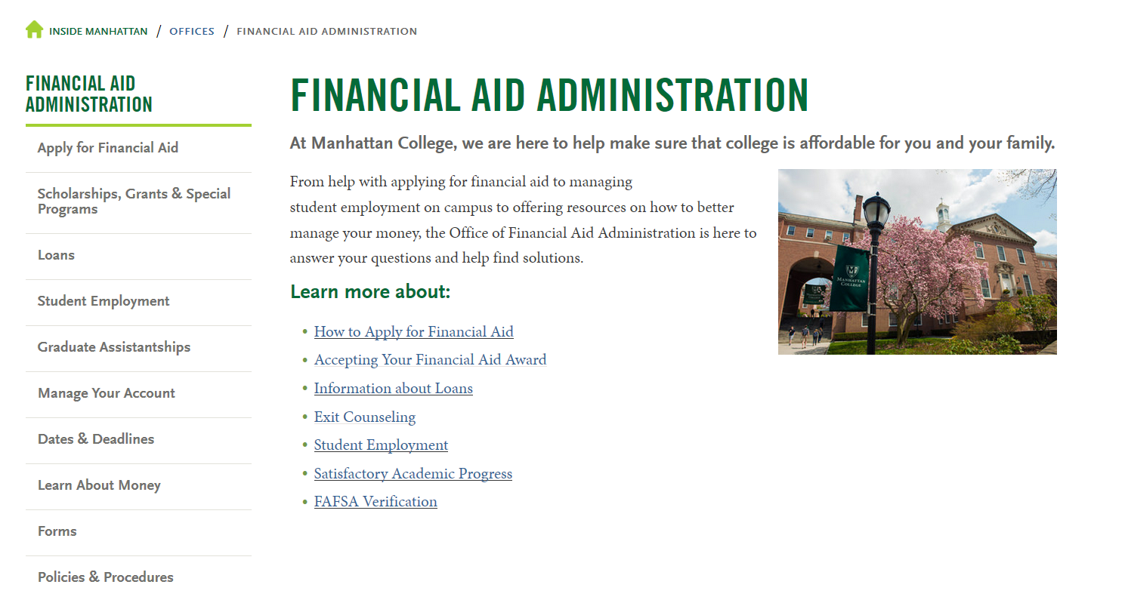

- Once on the Student Employment Page, students can apply to Federal Work Study and Campus Employment positions. Please note there is a difference between Federal Work Study and Campus Employment. To find out if you are eligible for federal work study or campus employment you can check your Financial Aid Award Letter on Self-Service or visit the Office of Financial Aid Administration, located on the third floor of Thomas Hall.

- Once a student has applied to jobs, they must wait for the supervisor to contact them for an interview. If a student is selected for the position, the student should advise Financial Aid of the hire so that they may receive an online payroll onboarding packet. The packet will include the W-4 tax form, I-9 Employment Eligibility Verification form, Student Employment Contract & Confidentiality Agreement, and an optional Direct Deposit form. The student must complete the packet and provide Financial Aid with official identification documentation for completion of the I-9 form. HOWEVER, if a student has worked on the Manhattan College campus before, they do not need to complete any paperwork.

- Once a student has completed the Onboarding, he or she will be eligible to work. The start date for the student is to be determined with the supervisor.

