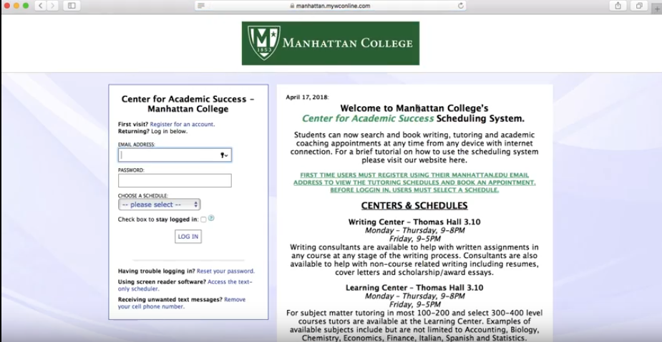
Step 1: Log onto https://manhattan.mywconline.com/. The right side of the screen will provide you information such as the CAS hours of operations, advice for scheduling appointments, CAS policies, etc. If this your first time visiting the website, click on “Register for an account.”

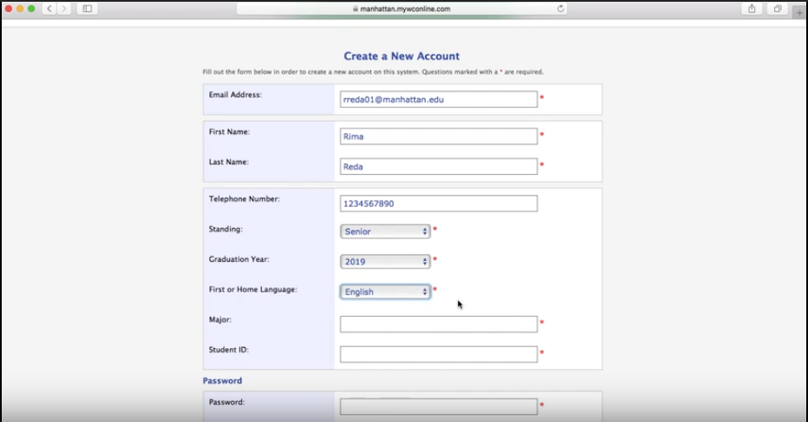
Step 2: Enter all the personal information required above.
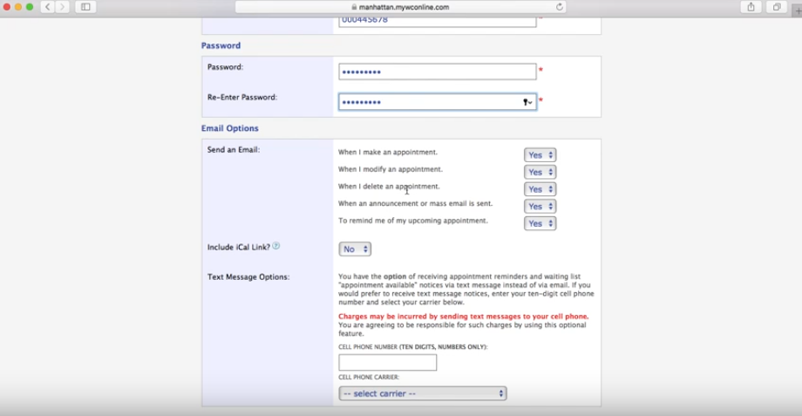
Step 3: It is recommended that you leave all email reminder options on. If you would like to receive text message reminders about appointments as well, enter your cell phone number and carrier down below.
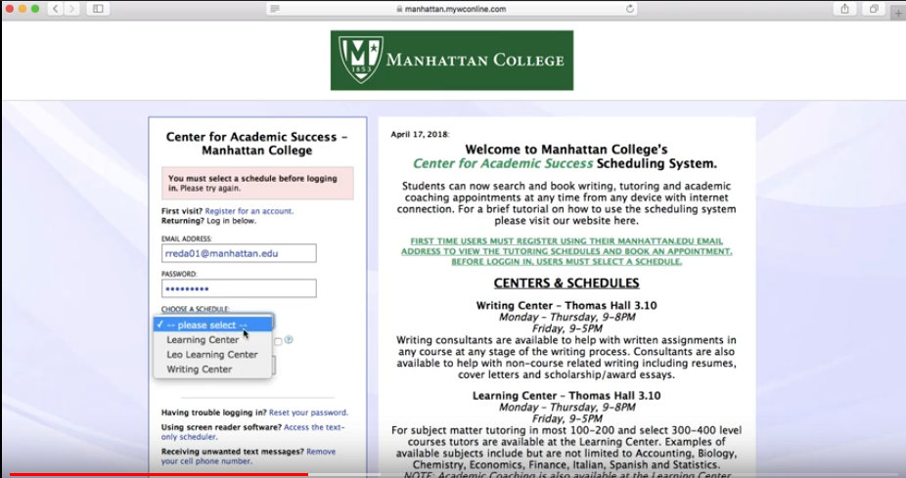
Step 4: After registering for an account, log in on the homepage with the email and password you created. To log in, you must select a schedule (Learning Center, Leo Learning Center, or Writing Center).
Learning Center: Located in Thomas Hall, tutoring is available for Business, Science, Language, and some Mathematics courses. Leo Learning Center: Located in Leo Hall, tutoring is available for Engineering, as well as some Science and Mathematics courses. Writing Center: Located in Thomas Hall, tutoring is available for help with any paper at any stage of the writing process, whether it be course-related or not.

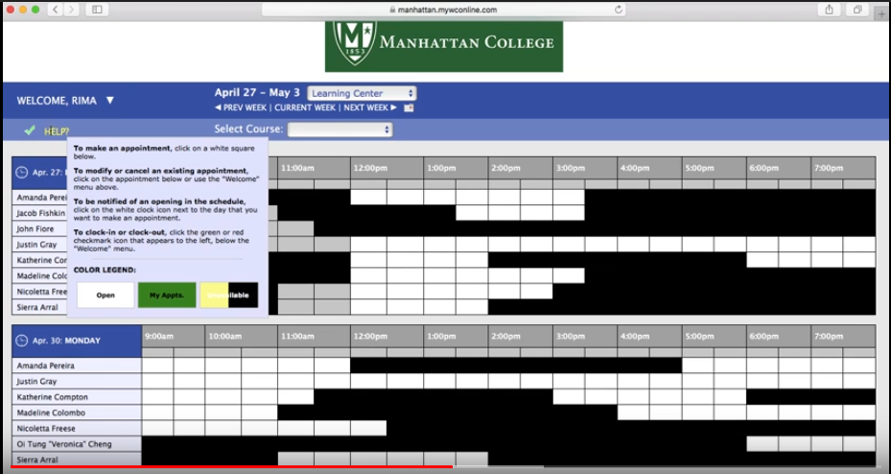
Step 5: After logging in, you will find a list of all the tutors available for the week. White means the tutor is available, Black means not working at that time, and Gray means the time has passed but the tutor is normally available at that time. If you need a reminder, toggle over the “Help?” button and the color legend will be provided.

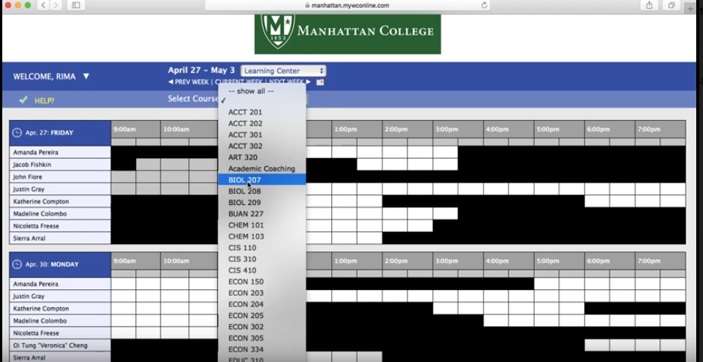
Step 6: Click the “Select Course” drop-down menu at the top of the screen to find the course you are looking for.

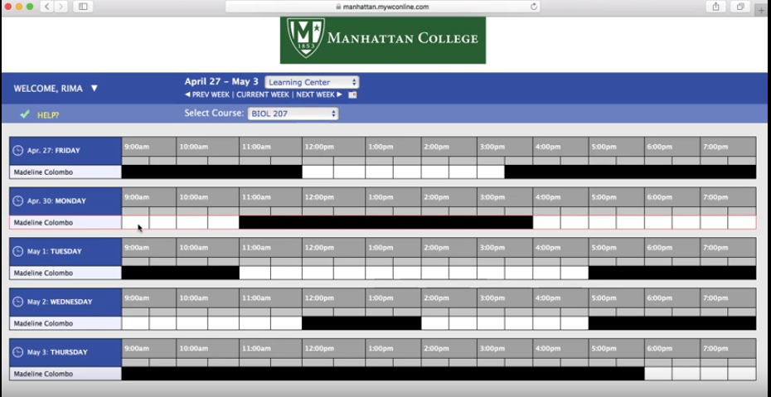
Step 7: Filter for “BIOL 207” for example, and you will find that Madeline is the tutor available for this course.

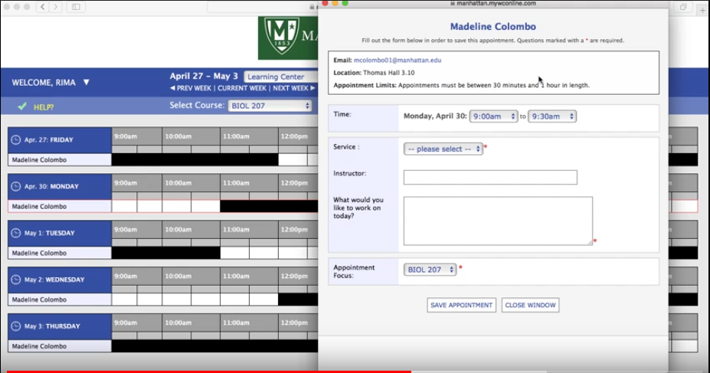
Step 8: Let’s say Monday at 9:00 a.m. works for you, click the white box under 9:00 a.m. and the pop-up on the right will appear.
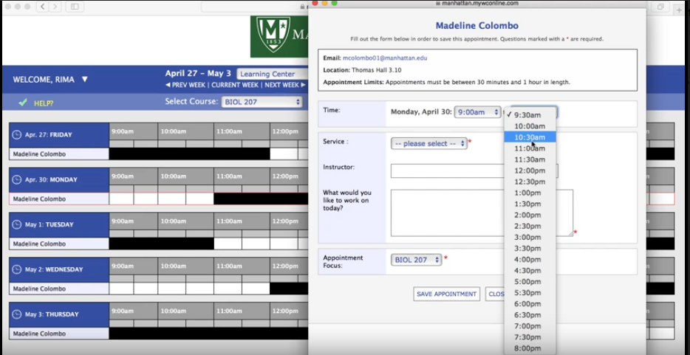

Step 9: Appointments can be anywhere from 30 minutes to an hour. If you would like an hour-long appointment, click the second drop-down menu and change the end time to 10:00 a.m.

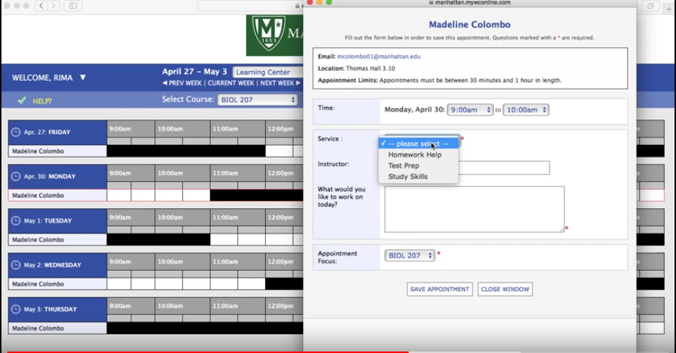
Step 10: For “Service,” select whichever service applies to what you need (Homework, Test Prep, Study Skills).

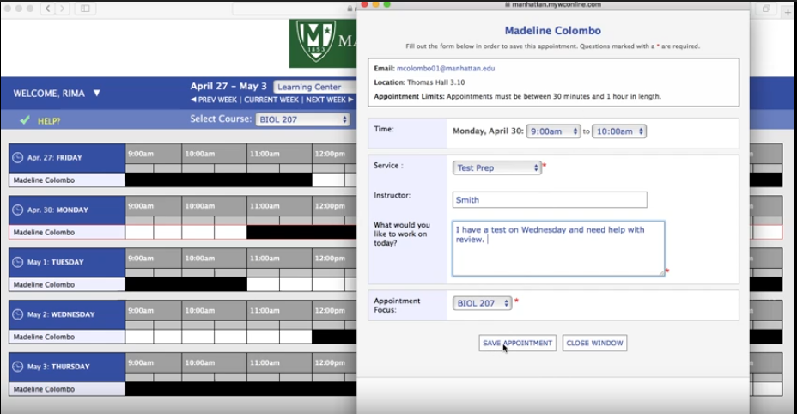
Step 11: Type in your Instructor’s name, and then type in what you would like to work on. This description can be made as specific as you like. After typing in the necessary information, click “Save Appointment.”
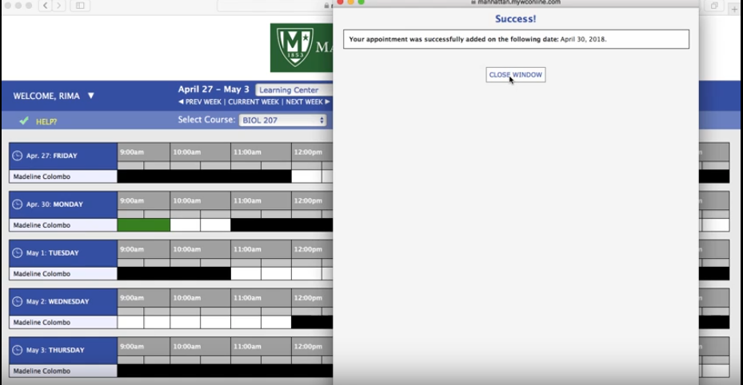
Step 12: You will then receive confirmation that your appointment has been successfully created. You will also receive an email confirmation.

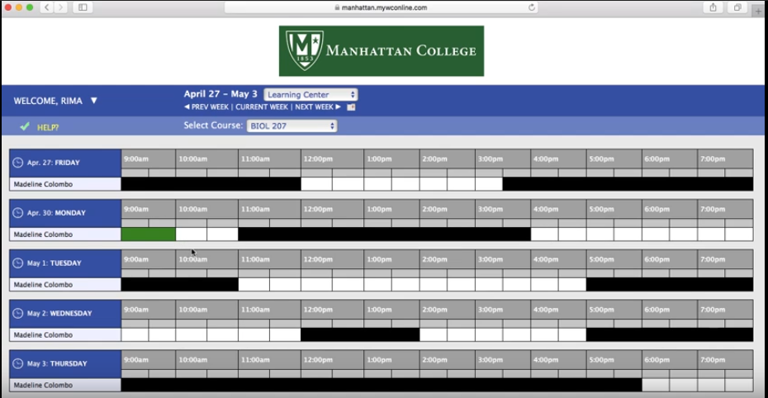

Step 13: The time slot is now green, which means you have successfully created an appointment for that time.

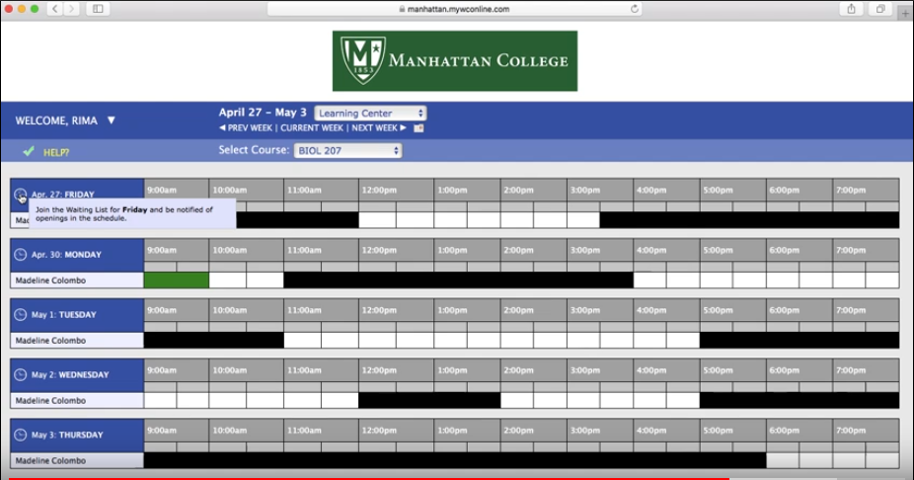
Step 14: If you couldn’t find any time that worked for you, or all the times you needed were already booked, click on the “Waitlist” icon for the day you want an appointment.
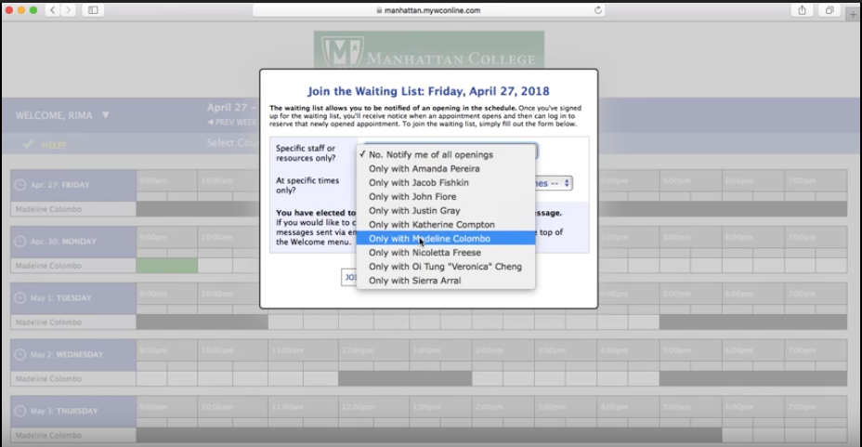
Step 15: After clicking on the Waitlist icon, this menu will appear. Choose one of the tutors on the drop-down menu that tutor the course you are looking for. (Remember, the tutors available for your desired course are found after filtering for the course. See Step 6). If you want tutoring for BIOL 207, for example, click the drop-down menu and select “Only with Madeline Colombo.”
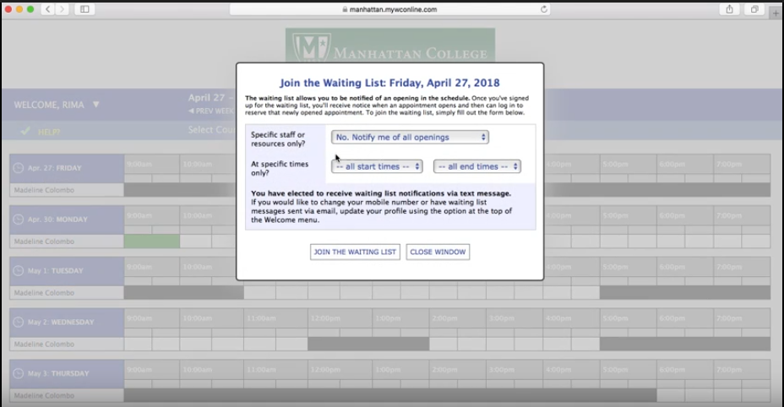
Step 16: If you want to be notified about anyone becoming available for that course, leave the option in the top drop-down menu as its default “No, Notify me of all openings.” This option would be used if you were coming in for a Writing Center appointment, as it wouldn’t matter which Writing Center Consultant you meet with.

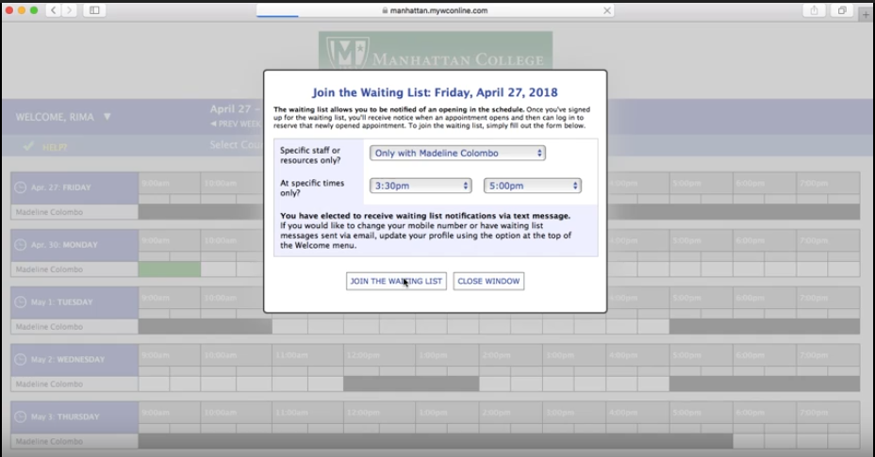
Step 17: You would then select the range of times on that day that work for you, and then click “Join the Waiting List.” You will then be notified about any openings during that time.

